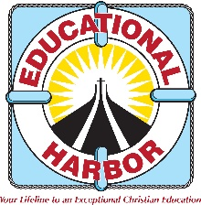
Educational Harbor Christian School
FLDOE 8290 * 415 49th St. East Palmetto, FL 34219 * 941-920-3935

RE: Entering High School
September 28, 2020

Dear Families,

As your student grows closer to entering high school at Educational Harbor, we would like to reiterate the high expectations and standards for high school with the following procedures:
- All students entering Educational Harbor High School will fill out their own application for high school, separate from the family application filled out by parents.
- Returning students will need a recommendation from their main teacher. New students will need the 2 reference letters as part of the intake process.
- Students will need to write a 3-paragraph essay on why they want to continue or begin high school at Educational Harbor, and how this education will benefit them.
Students may enter high school before 9th grade if they show academic and social aptitude necessary for success in high school courses.
All students will need to demonstrate social aptitude necessary for academic success during their middle school years at Educational Harbor or as mentioned in the referral letters (if new). This includes following directions immediately, listening quietly, and doing their best to complete schoolwork on time, and positive interaction with peers and teachers based on the student handbook. If they are unwilling or unable to adjust their behavior to fit this standard, then we will assist in recommending a different high school for your student.

Thank you for your continued support!

With love,

Stacey Mayo, Principal Stephanie Powers, Assistant Principal

